***Complete Cargo Forklift Packs***

This pack allows you to do a forklift truck simulator, including the basic elements that you need. All UI menu's, models, scripts and scenes are included.

**About controls:**

- a,s,d,w – Move ForkLift(newCarUserControllerNew.cs);

- Page Up, Page Down – move ForkLift platform (ForkController.cs);

- C – change camera;

- Q,E, swipe – rotate camera.

**About Forklift**

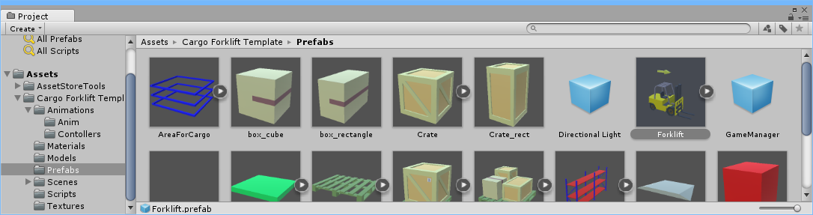

Drag prefabs forklift truck

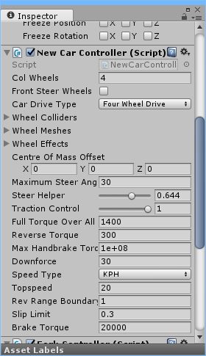

And configure the controller or use standard parameters

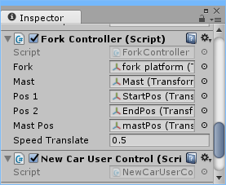

For forklift truck using the optional script:

ForkController.cs - The script for the management platform forklift.

In this script, you can customize the speed settings, the minimum and maximum height of the mast and fork platform.

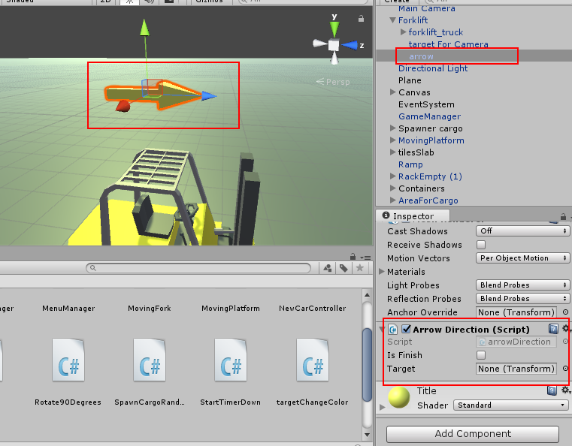The player showed the direction, you need to add an arrow and a script "arrowDirection.cs." In prepare forklift already has an arrow. In prefab forklift already has an arrow. The script looks for the target tags "Finish" and "Cargo".

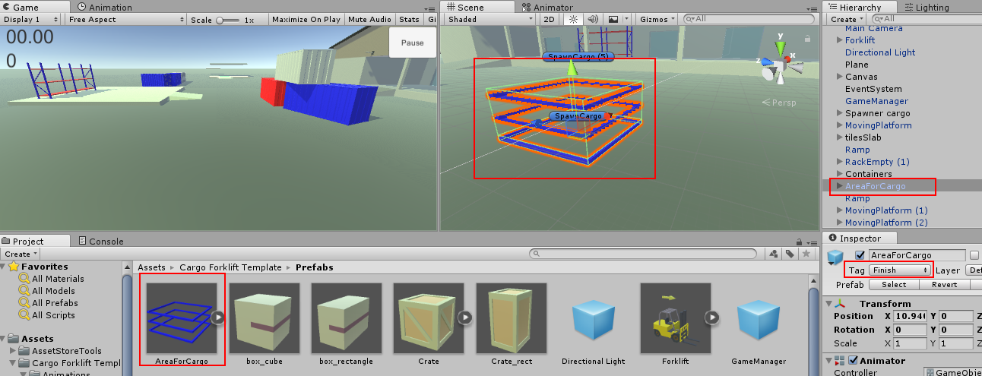To do this, add the tag "Finish" on the object "Area for Target" if it is not. In the prefab it is already.

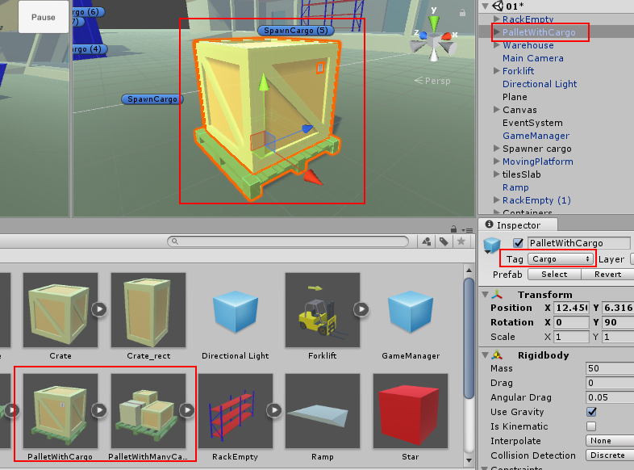

Tag "Cargo" needs to be added to the package you want to in the game.

For forklift platform you need to add the tag "ForkPlatform". 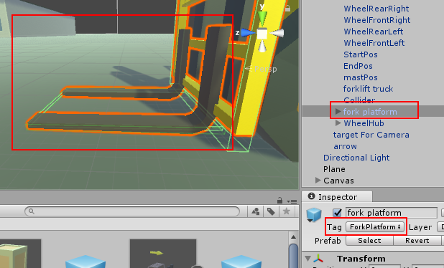

**About Camera**

So the camera watched a forklift being used the script:

Rotate90Degrees.cs - This script monitors the target and using the buttons Q and E or touch the camera rotated 90 degrees.

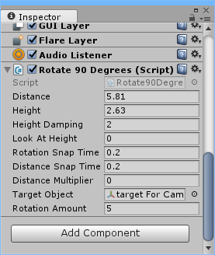

In the «Target Object» field insert the object you want to follow the camera

**GameManager**

In Game Manager are logic games, game panel, sound settings.

**About Area for cargo**

After the forklift truck will take the cargo, there will be area for cargo. It is necessary to put the cargo:

* to increase the number of seconds;
* to increase the quantity of transported goods.

On the "Area for cargo" script "targetChangeColor.cs." And a child object "emptyTarget (0)" is script "CargoFinish.cs."

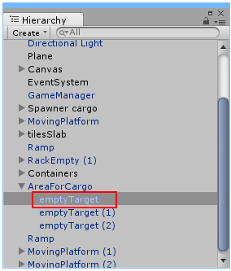Script "targetChangeColor.cs" is responsible for the color change "Area for cargo".

For the detection of the load responding "emptyTarget (0)". It is the "Box Collider" as a trigger and a script "CargoFinish.cs."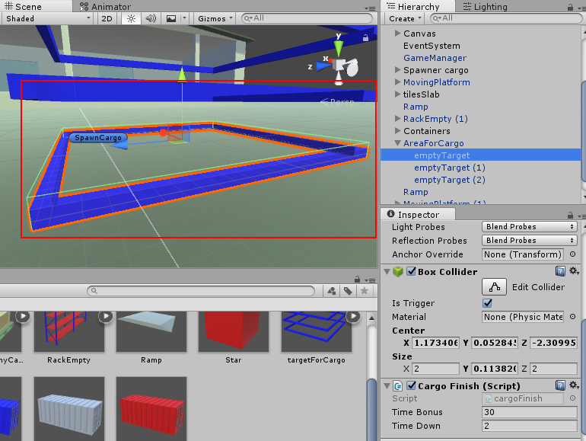

To change the number of added seconds to change the number of "Time Bonus".

"Time Down" is responsible for the countdown to the removal of the cargo and hide "Area for cargo"

**About Cargo**

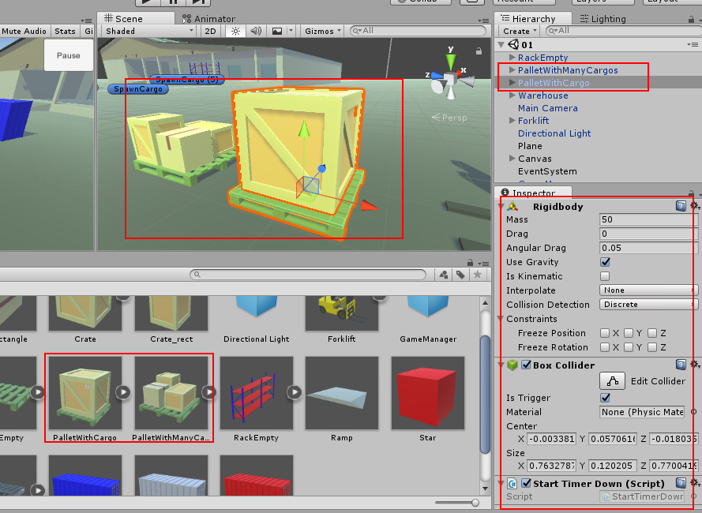

Drag the prefabs of the load on the stage or create your own. Add a "RigidBody", the Collider and the script "TimerDown.cs." The Collider need to put that it is a trigger. This script needs to determine. The script is designed to determine the forklift platform. If the forklift platform has entered the Collider, then the method is called the emergence area for the cargo.

**About Spawner cargo**

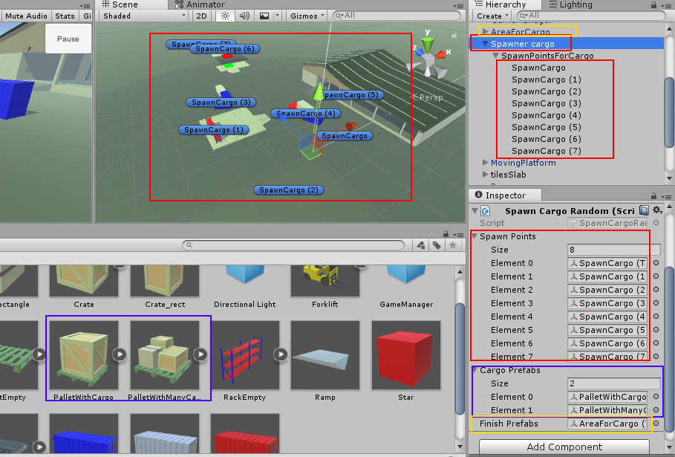

Add the script "SpawnCargoRandom.cs" on the object in the scene.

To the goods appearing in the right positions you need to place spawn points in the scene. Then move them to the array "Spawn Points". Move prefabs goods in array "Cargo prefabs". Move "Area for Cargo" in the field "Finish prefabs"

**About Moving Platform**

Create an empty object in the scene and name it for example "Moving Platform". Add the script "MovingPlatform" this empty object. Create two empty object "StartPosition", "EndPosition". Add on stage a platform that has to move. Move "StartPosition", "EndPosition", a platform in the parent object you created in the beginning.

Add "StartPosition", "EndPosition", a platform and a mesh platform in the corresponding slots of the script. Adjust the speed of the platform and the time countdown.

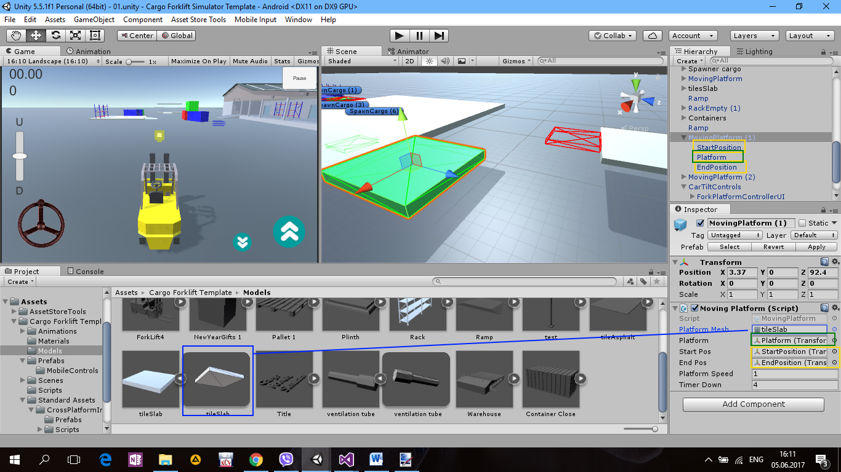

**About Mobile Controls**

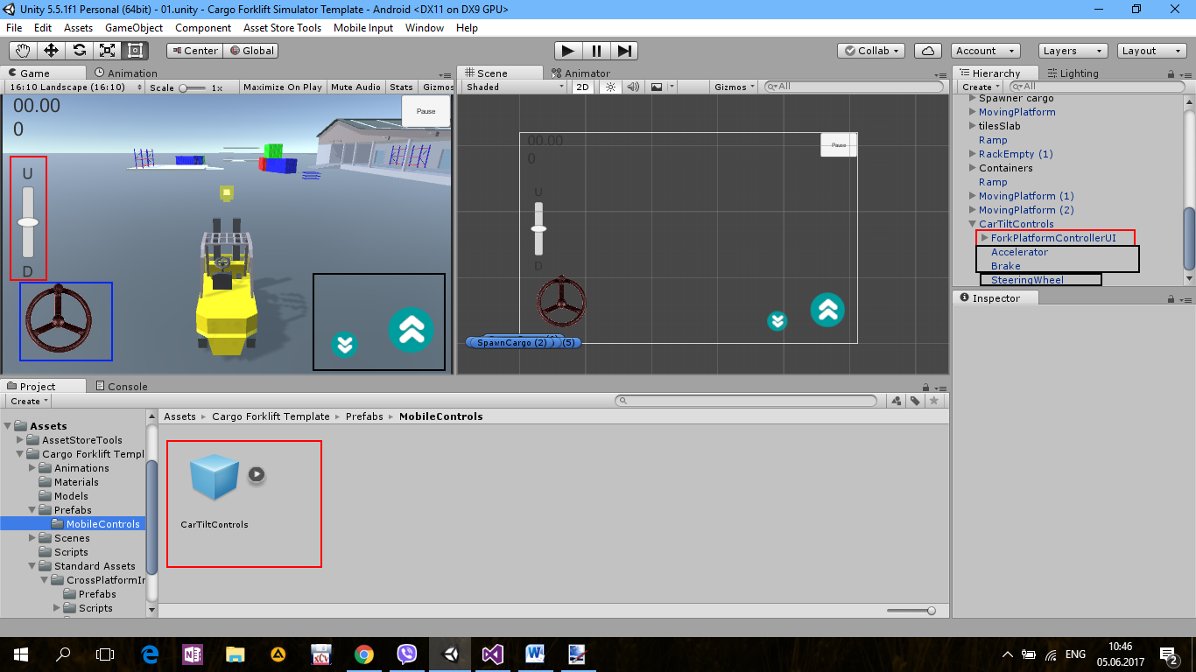

Add prefab "CarTiltControls" on stage. It consists of:

- Steering wheel

- Buttons gas and brake/reverse

- Button control forklift platform. Up, down.  
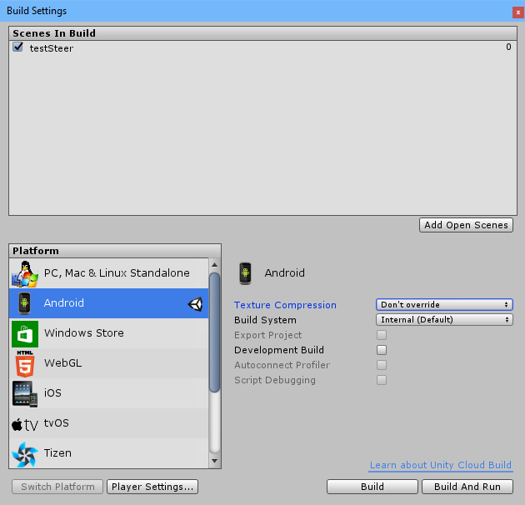

To make the buttons visible in the "Build Settings" to choose the Android platform